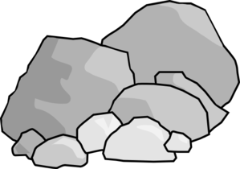
Composition of Rocks:

1. Describe the composition
of rocks in the textbox to the right.

2. Describe how each type of rock is formed in the boxes below.

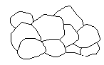  Igneous Rock | Metamorphic Rock | Sedimentary Rock

3. Identify the processes that can change the rocks from one to another.

Igneous Rock
Metamorphic Rock
Igneous Rock
Sedimentary Rock
Metamorphic Rock
Sedimentary Rock
Metamorphic Rock
Igneous Rock
Sedimentary Rock
Metamorphic Rock

Composition of Rocks:
mixtures of minerals, rock fragments, organic matter, or other natural materials

Forms from hot molten lava or magma that cools and crystallizes  Igneous Rock | forms by the deposition of rocks and other sediments that become compacted and cemented  Forms when a rock is changed by heat and or pressure  Metamorphic Rock | Sedimentary Rock

Heat and Pressure
Igneous Rock
Metamorphic Rock
Weathering/Erosion then Compaction/Cementation
Igneous Rock
Sedimentary Rock
Weathering/Erosion then Compaction/Cementation
Metamorphic Rock
Sedimentary Rock
Melting &Cooling of Magma
Metamorphic Rock
Igneous Rock
Heat and Pressure
Sedimentary Rock
Metamorphic Rock

